-

**SEO And Digital Marketing**

**(Summer Internship 2021)**

*Presented by: -*

**I PRASANTI**B.Tech.(CEN), 3rd Semester  
SIC: 20BCEA56



Silicon Institute of Technology  
Bhubaneswar

Table of Contents

1 Introduction 2

2 Objectives 3

3 Contents of the Program 4

3.1 Digital Audit 4

3.2 SEO Audit 4

3.3 My Digital Property 4

3.4 Google Ads 5

3.5 Social Media 5

4 Methodology 6

5 Details of Works done during the Internship (on daily/weekly basis) 7

3.5 Work done in first week 7

3.5 Work done in second week 10

3.5 Work done in third week 13

6 Outcomes of the program 17

7 Conclusions 18

8 Acknowledgements 19

# Introduction

As a part of my Summer Internship Course I have done 4 weeks internship (9th August 2021- 31 August 2021) in **‘SEO and Digital Marketing’** from Syllogistek System Private Limited, Hyderabad.

**Digital marketing is the marketing of goods and services via digital technologies**. The Internet, for example, is a type of digital technology. However, it is not the only one. Digital marketing also includes marketing services and products using display advertising, mobile phones, and other digital media. It is the process of building and maintaining customer relationships through online activities to generate sales and/or capture customers that are searching on the Internet for answers/information.

SEO stands for Search Engine Optimization. It is the process of getting traffic from the free, organic, editorial, or natural search results on the search engines. Simply put, it’s the name given to the activity that attempts to improve search engine rankings. In many respects, it's simply quality control for websites.

SEO may target different kinds of search, including image search, local search, video search, and news search engines. Employing a sound SEO strategy helps us to position our website properly to be found at the most critical points in the buying process or when people need our site.

It is technically a marketing tool rather than a form of marketing in itself. [T](https://www.thebalancesmb.com/search-engine-optimization-2948419)he balance defines it as “the art and science of making web pages attractive to search engines.”

The "art and science" part of SEO is what’s most important. SEO is a science because it requires you to research and weigh different contributing factors to achieve the highest possible ranking. Today, the [most important elements to consider](https://www.searchenginejournal.com/seo-guide/ranking-signals/" \l "close) when optimizing a web page include:

* Quality of content
* Level of user engagement
* Mobile-friendliness
* Number and quality of [inbound links](https://mailchimp.com/marketing-glossary/backlinks/)

The strategic use of these factors makes SEO a science, but the unpredictability involved makes it an art.

# Objectives

* The awareness of digital marketing among business holders.
* To study awareness of digital marketing among business holders
* To study need and interest of digital marketing services
* To study the growth of digital marketing among business holders
* To study the effectiveness of digital marketing among business holders
* study on digital marketing services
* To study different digital services
* To study different digital marketing services impact
* To study about how the digital services work
* To study the impact of digital marketing among people
* To study the use of digital services
* Importance of web designing and social media engagement for business
* To study online presence of business and its services
* To study social media presence and promotion of products and services
* Easier access to online services through web and social media
* To increase client engagement & generate leads

# Contents of the Program

## DIGITAL AUDIT

* Target Audience Analysis
* Sample of your audit of local business
  + Page load time
  + Responsiveness
* Device Responsiveness
* Browser Responsiveness
  + Broken Links
  + Content Plagiarism
  + Recommendations

## SEO AUDIT

* Findings from Screaming Frog (along with screenshot)
* No.of backlinks from Backlink checker (along with its screenshot)
* Recommendations

**3.3 MY DIGITAL PROPERTY**

* Blog Creation
* Creating account in Google Analytics and adding it to blog
* Creating account in Google Search Console and adding it to blog

**3.4 GOOGLE ADS**

* Creating account in Google Ads and adding it to blog
* Searching of Keywords
* Creating Ad copies
  + Text Ads
  + Image Ads
  + Video Ads (with proper placement)

**3.5 SOCIAL MEDIA**

* Facebook Page for Blog
  + Creating Facebook Campaign
* Instagram Page for blog
  + Promoting pictures
  + Setting targets
* YouTube Page for blog
* Linkedin page for blog

# Methodology

1. Digital Audit
2. SEO Audit (Search Engine Optimization)
3. Creating a blog
4. Google Ads
5. Content Marketing
6. Social Media Marketing

# Details of Works done during the Internship (on daily/weekly basis)

**1st Week ( 9th August 2021 to 14th August 2021):**

* Assignment on the **Target Audience** of a local store
  + Local Store Name : DARPAN FURNISINGS
  + Details about the store (location, family background, goals)
  + Recommendations

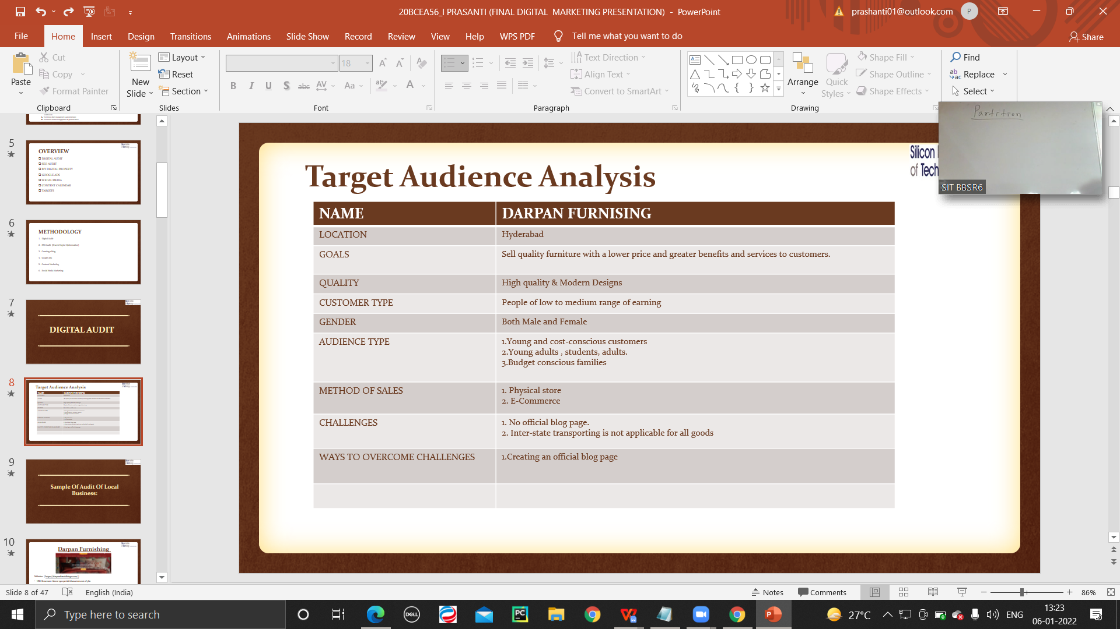

* Studied about content marketing
* Assignment on **Digital communication**
  + Local Store Name: Archis
  + Caption for a product of a local business
    - Written caption on Mortice Handle
* Studied about SEO Audit
* Studies how to use Screaming Frog
* Assignment on the **Audit of local business** (with a ppt)
  + Local Store name: Darpan Furnishing
  + Target audience analysis
  + Checked its website using screaming frog
  + Checked its device and browser responsiveness
  + Checked broken links of the website using Screaming frog
  + Checked content plagiarism
  + Recommendations

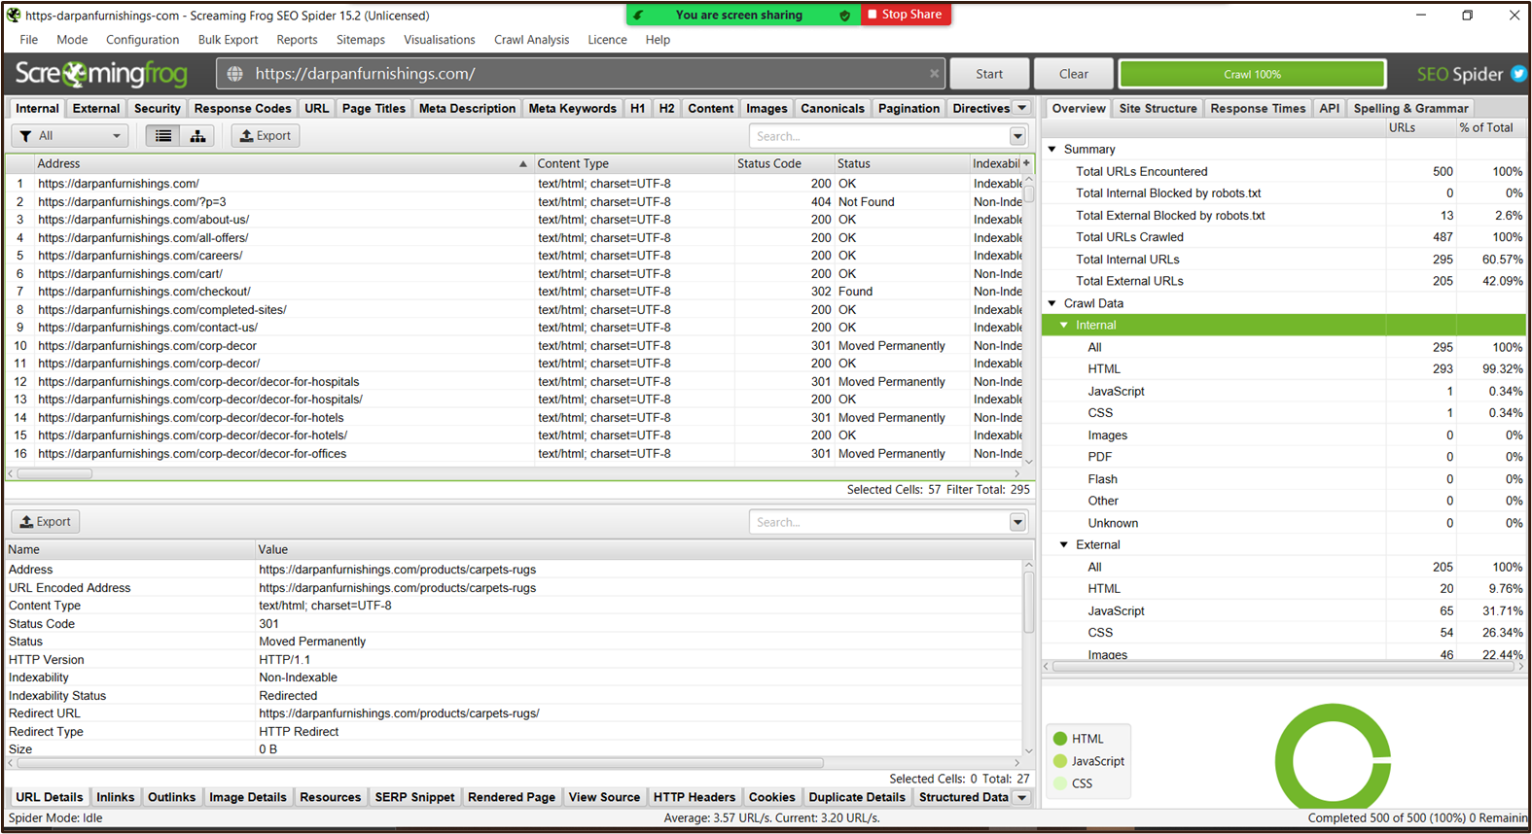

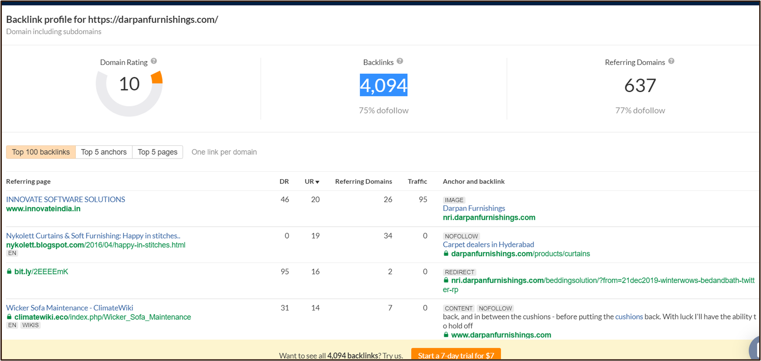

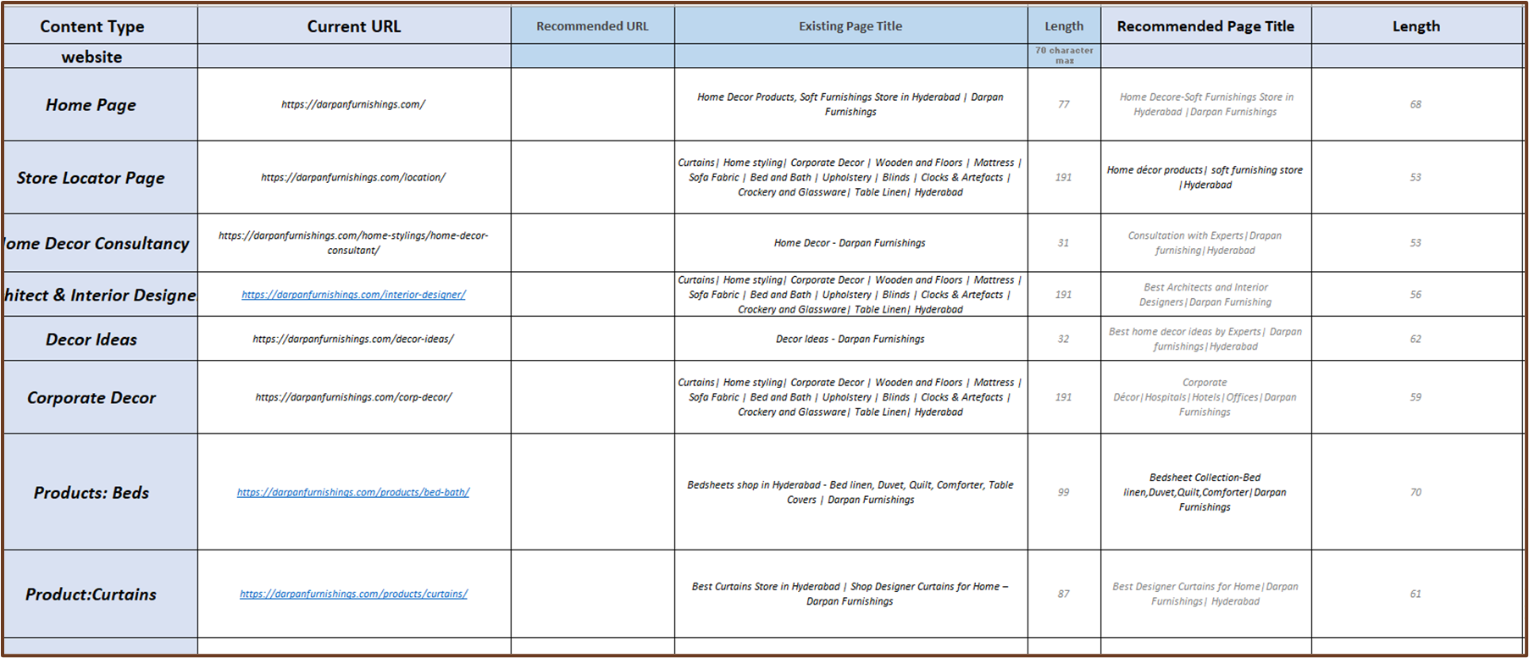

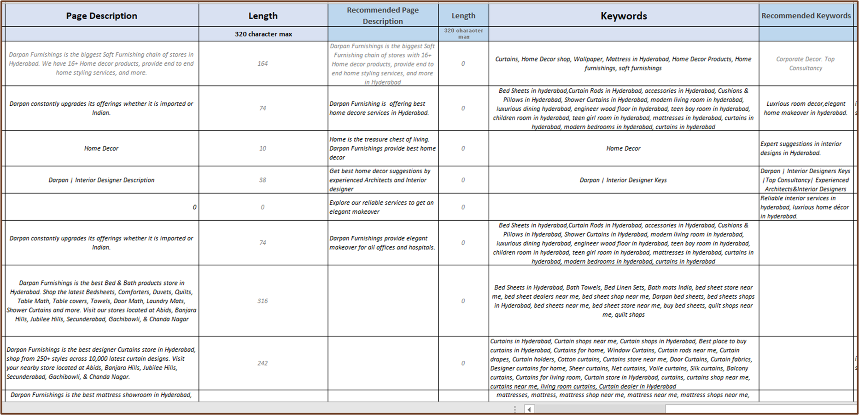

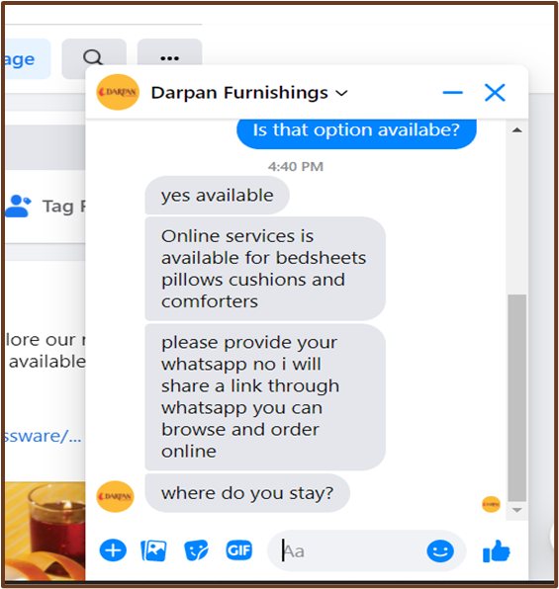 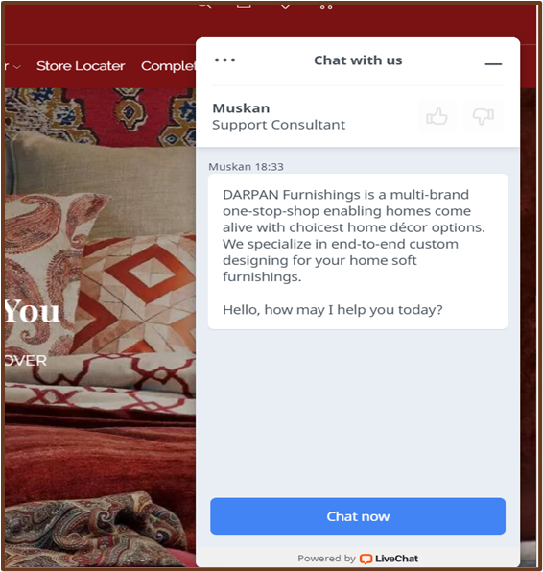

( Call To Action Screenshot)

**2nd Week ( 16th August 2021 to 21st August 2021):**

* Studied about various business models and affiliate marketing
* Assignment on Business model and its case study
  + Created a list of various business models along with its products and examples of such companies in MS Excel.
* Studied about how to make blog
* Assignment on **Mindmap** for the blog
  + Created a Mind-map for my blog by using Mindmup 2.0
* Studied about heatmaps using hotjar website
* Studied about Google Adsense along with Adwords Campaign,customization,Ad Shedule, Audience Manager and its configuration.’
* Assignment on **Blog Creation**
  + Created a Blog on PLASTIC FREE HOME.
  + Created analytics : Heat-maps, Ad-sense

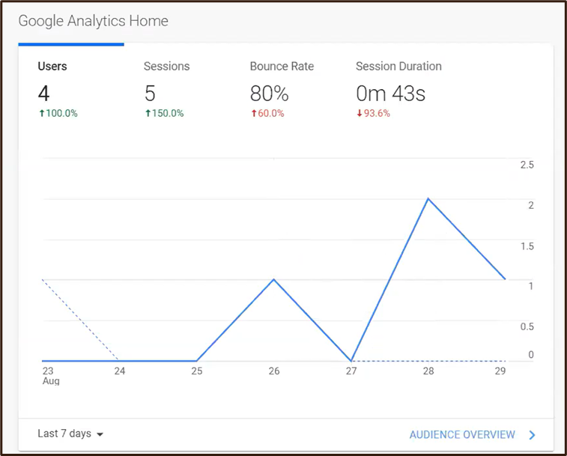

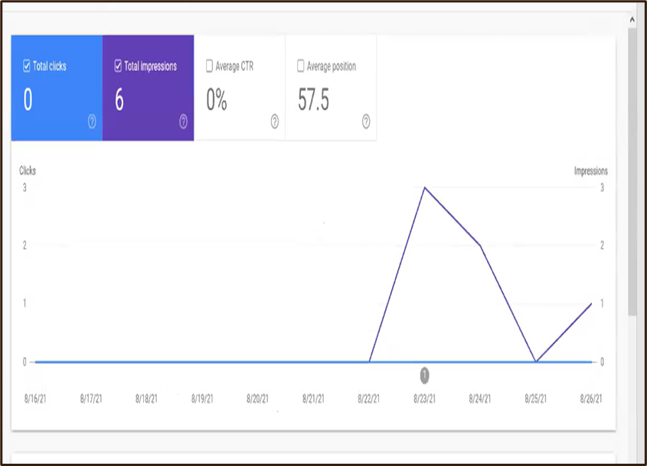

* Studied about Google Ads, campaign setup, keyword planner.
* Distribution of error in Google Ads and high & low range in keyword planner.
* Studied about Ad Extensions, site link extensions.
* Assignment on **Google Ads** Creation
  + Made an account in Google Ads and attached it to the blog analytics.
  + Created a campaign in Google Ads for the blog
  + Made a list of all the keywords and segregated it according to its match type (Broad match, Phrase match, Exact Match) in MS Excel.
  + Made Ad Copies
    - Text Ads
    - Image Ads
    - Video Ads, using Canva and made a list in MS Excel.

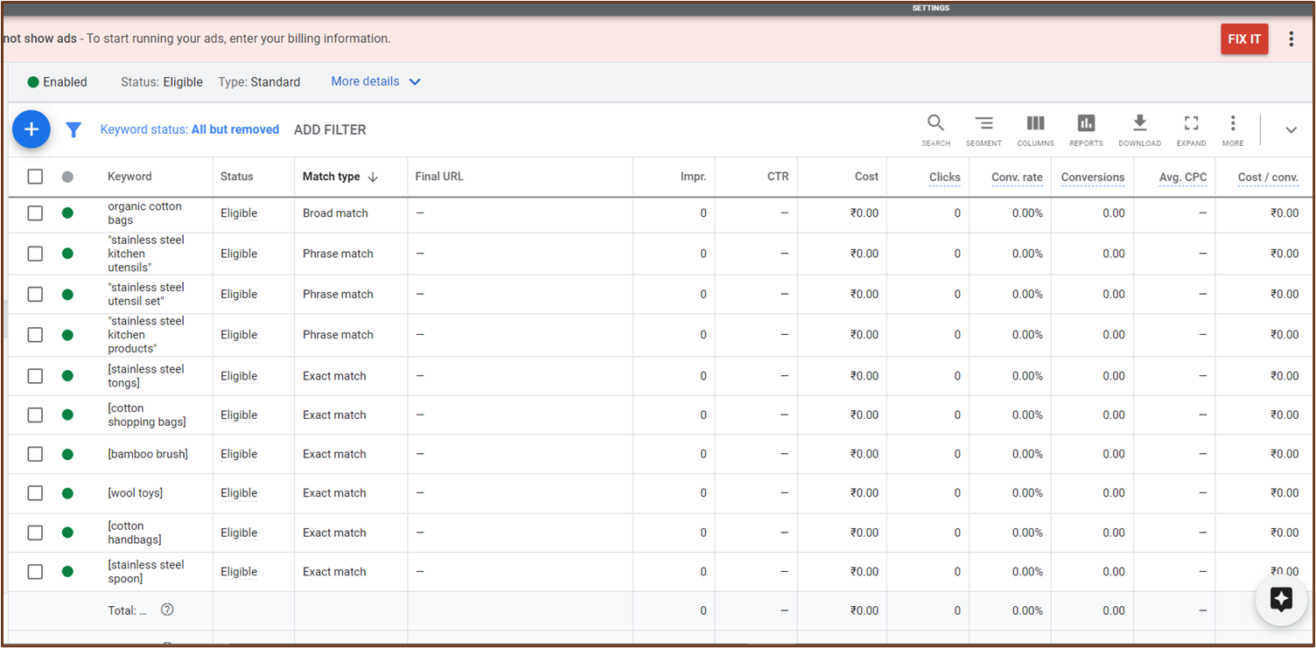

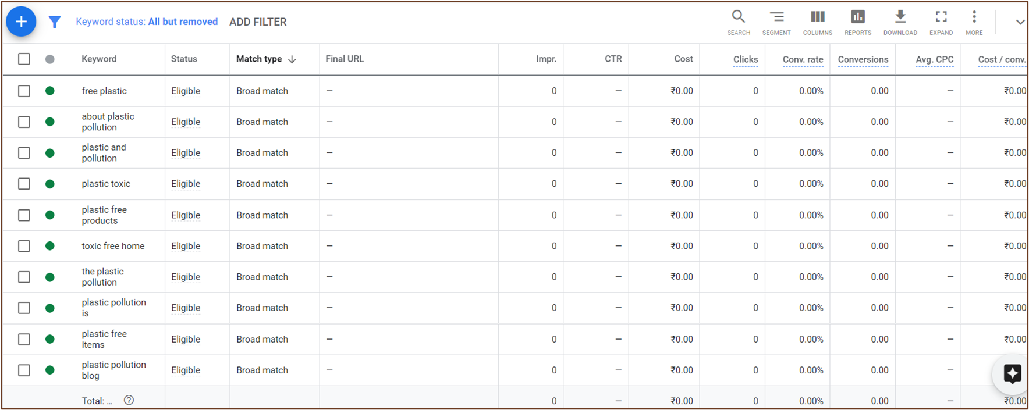

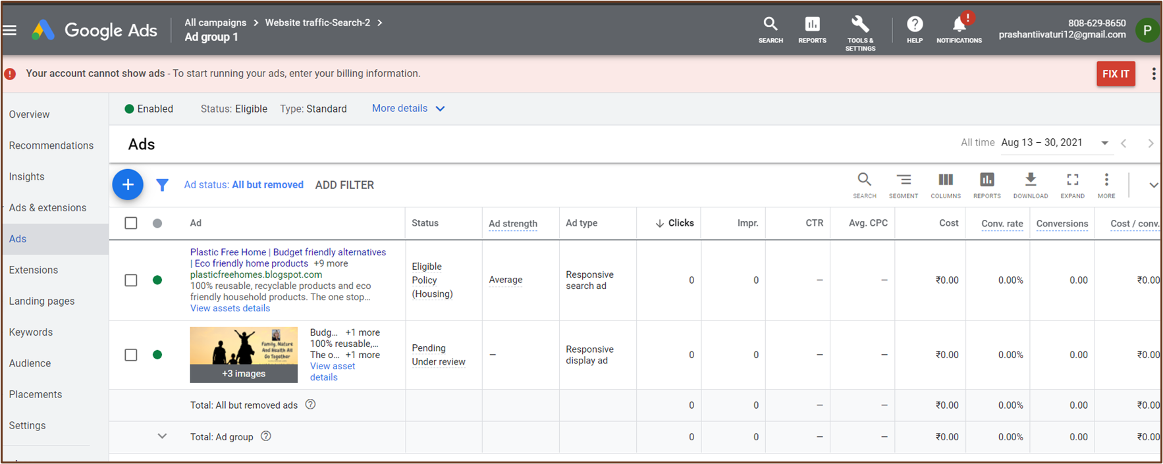

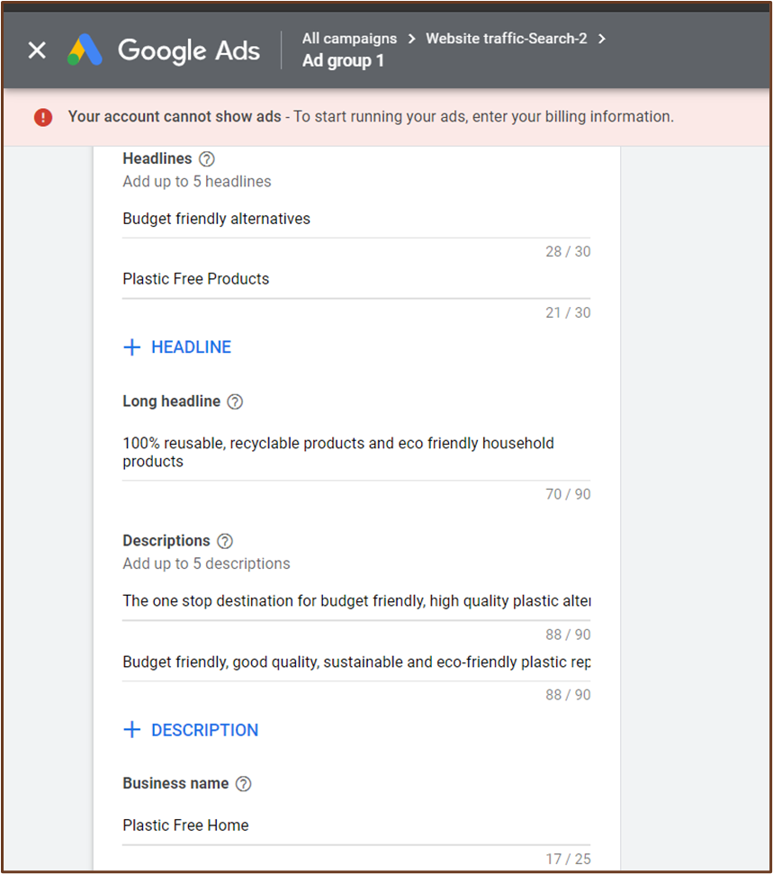

**3rd Week ( 23rd August 2021 to 31st August 2021):**

* Studied about Digital Properties
* Studied about Digital marketing target audience, Flywheel Model, Domain and Hosting
* Studied about content in editing pictures, about prices,offers and benefit values.
* Assignment on Creating **Image Ads using Canva**

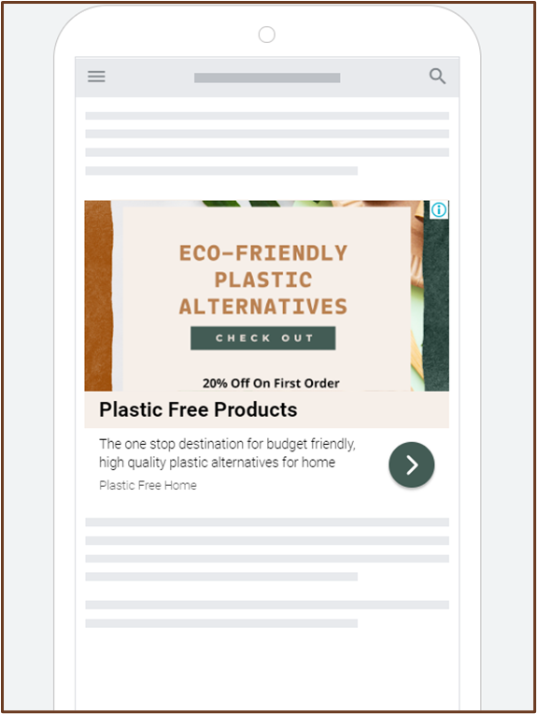

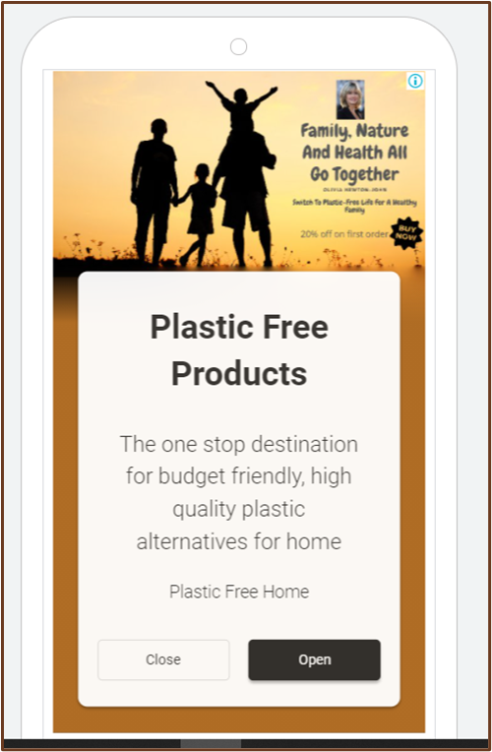 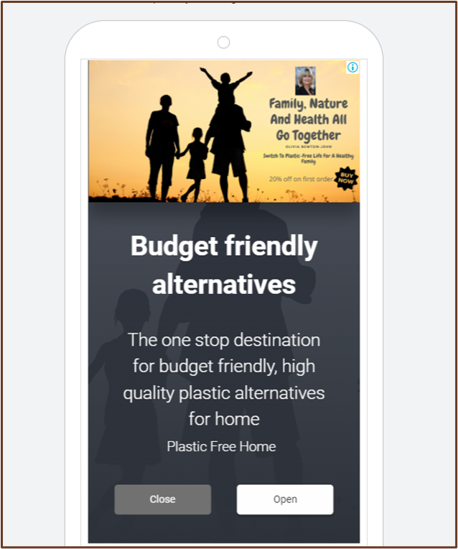

* Assignment on **Creating Social Media Pages** for the blog.
  + Created a Facebook Page for the blog
    - Created its business account.
    - Created a business suite, pixels,insights,target audience,comparisons,Ads promotions.

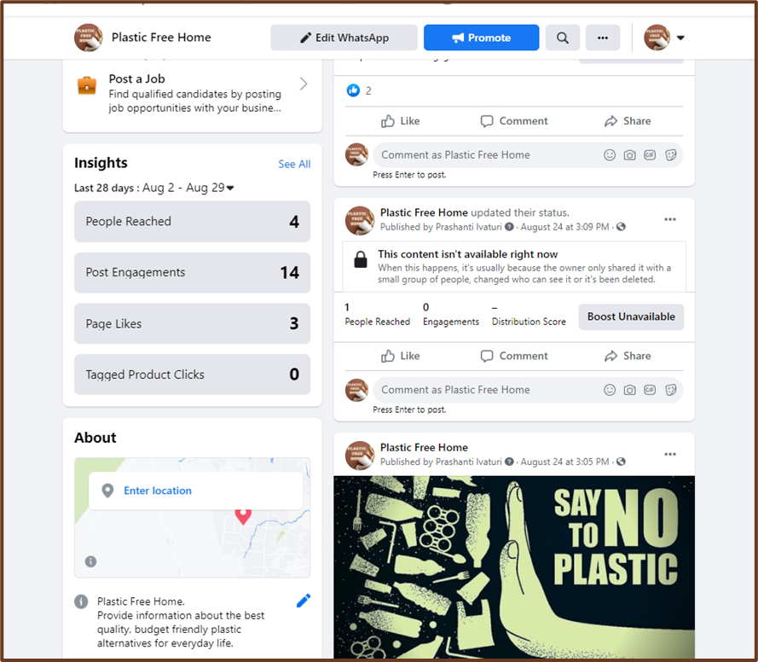

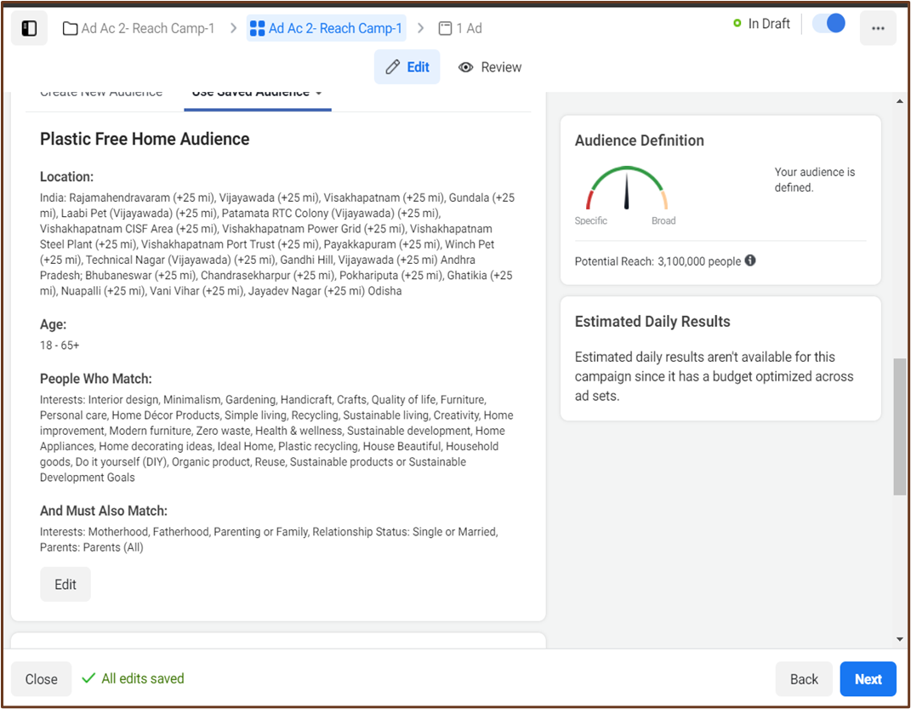

* Created an Instagram Page for the Blog
* Created its business account
* Posted Pictures related to the blog and created its promotions.

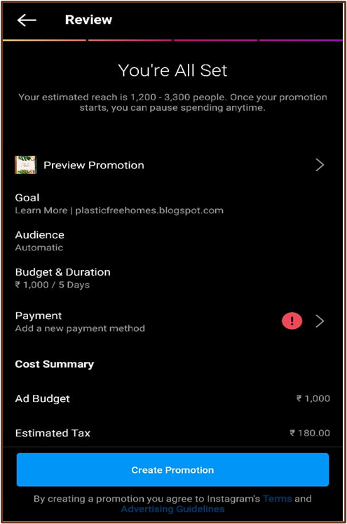

* Created a YouTube Channel for the Blog.
* Created a Linkedlin Page for the Blog.
* Added all the social media accounts with the blog for promotion.
* Made a **Content Calendar**
* Made a Final presentation with all the work done along with screenshots.

# Outcomes of the program

* It is very auspicious to be a part of a well-developed internship program and the curiosity is even more when availed this opportunity in the very first year of our graduation program. This program helped me to understand the world of digital marketing in a well-structured manner, and has now given me multiple pathways to expand my knowledge in it.
* We learned about digital marketing and its importance in present world. We also studied about various digital marketing services available to us which we can use in order to improve our business in a small scale as we can use this to create a massive impact on our target audience.We also learned about the growth of digital marketing among business holders and its effectiveness.
* We learned about SEO audit and the importance of auditing our website or business page regularly. Since our website is the hub of all the online brand it is very important for us to have regular checkups to ensure everything is in correct order. We learned about Screaming Frog which we can use to monitor our websites correctly.
* We learned how to create and manage different Social Media Accounts like Facebook,Instagram,YouTube,Linked-in.We also learned how to keep make business account and promote stuff through this. And we also learned about Digital Ethics.
* This course not only gave me basic idea about Digital Marketing but also taught me ways of implementing theories in the practical world and gave ideas of applying effective solutions and using modern tools and techniques in real life small scale business and startups.

•

# Conclusions

* An insightful experience.
* I feel extremely fortunate that I had the opportunity to experience the online mode for my internship which taught me a lot about the course.
* I am thankful of my college and SYLLOGISTEK SYSTEM PRIVATE LIMITED for giving such a wonderful platform for us to learn even under the cloud of such ongoing pandemic.

# Acknowledgement

I would like to express my gratitude towards SYLLOGISTEK SYSTEM PRIVATE LIMITED, HYDERABAD and SILICON INSTITUTE OF TECHNOLOGY, BHUBANESWAR for giving me this learning opportunity. I am grateful to my teacher Avik Mitra sir for guiding me throughout the project. I also express my kind gratitude towards Abhijit Sen sir , Kasturi Dhal Ma’am and Pamela Choudhary Ma’am for their constant supervision. I am thankful to my batchmates who were very cooperative and helpful throughout the learning period.